Reporting & Valuation Architecture
From Item Configuration to Financial Reporting
Costing, GL Impact & Valuation Flow in NetSuite
Understanding the Financial Backbone of ERP
Weekly Learning Series – Week 8

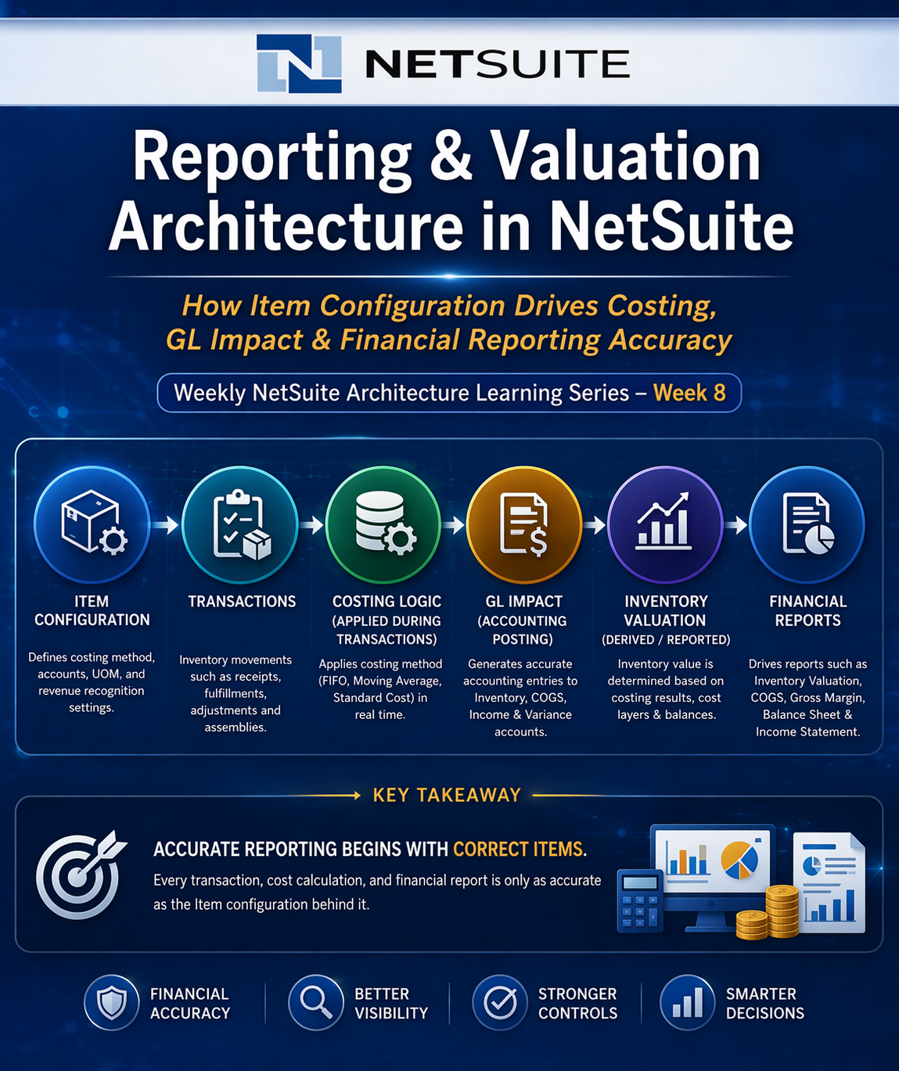
Introduction
- In NetSuite, Items are not merely operational records used for purchasing or selling goods.
- They are foundational elements that directly influence how transactions are processed, how costs are calculated, and how financial data is ultimately reported.
- Every inventory movement, cost calculation, and financial posting originates from the way an Item is configured. This includes key aspects such as costing method, General Ledger account mapping, Units of Measure (UOM), and revenue recognition settings.
- As a result, Items act as a critical bridge between operational activity and financial outcomes.
- This document explores how Item configuration drives the end-to-end flow within NetSuite, starting from transaction processing and costing, through to inventory valuation and financial reporting.
- It highlights the dependencies between these layers and explains how misconfiguration at the Item level can propagate across the system, leading to reporting inaccuracies and financial discrepancies.
- Understanding this architecture is essential for:
- Designing reliable and scalable NetSuite implementations
- Ensuring financial accuracy and audit compliance
- Building automation and reporting solutions on a stable foundation
- Ultimately, this document reinforces a key principle:
  - In NetSuite, financial accuracy begins with correct Item configuration.
- All item-related transactions ultimately generate General Ledger (GL) impact, which serves as the foundation for financial reporting.

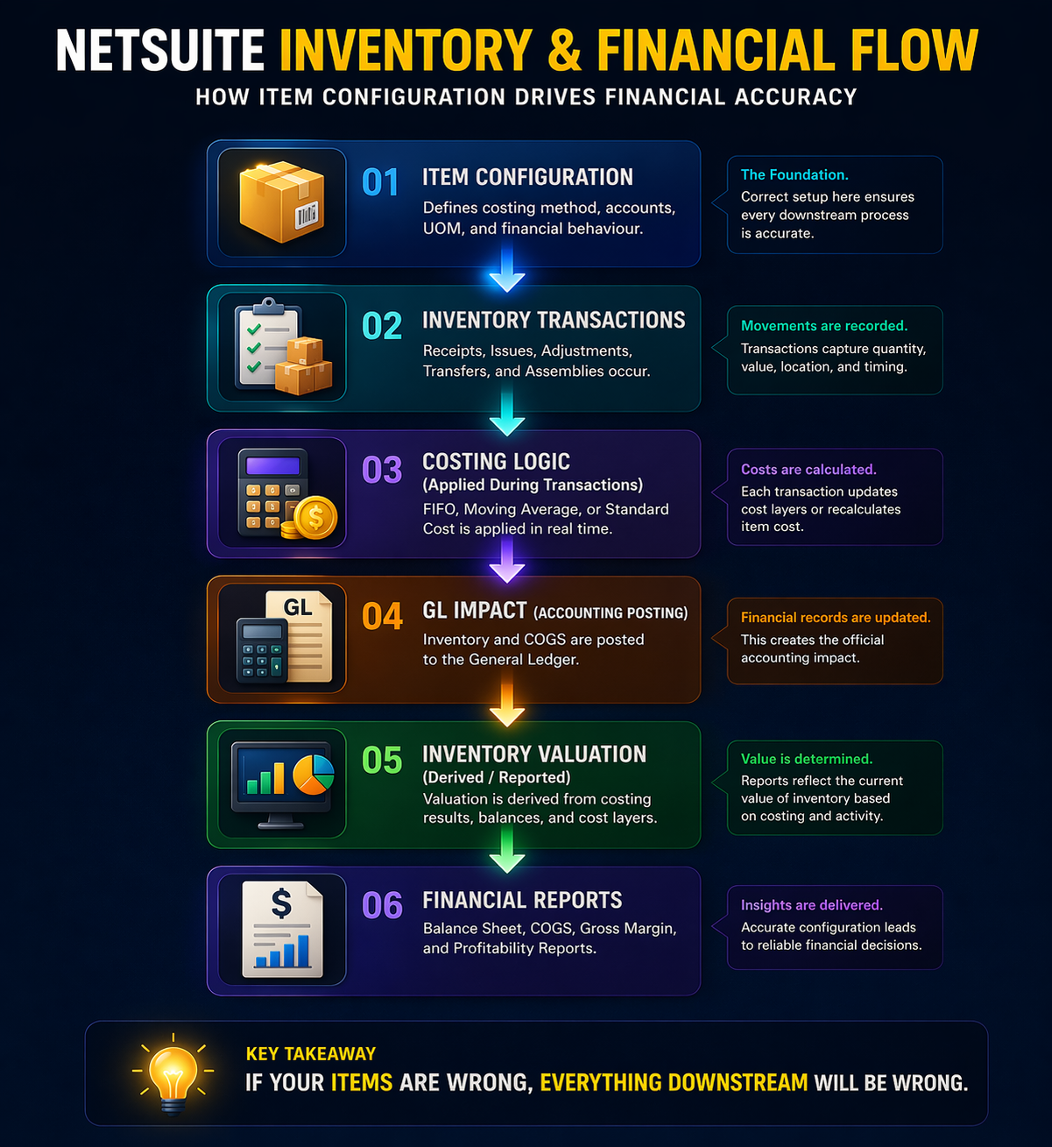

Reporting & Valuation Architecture
Overview
- Item configuration is a foundational driver of financial and inventory reporting within NetSuite.
- Items determine:
- Inventory valuation method (FIFO, Moving Average, Standard Cost, etc.)
- Cost recognition behavior (COGS timing and calculation)
- Revenue recognition linkage (via item-to-account mapping or revenue elements)
- Because of this, Item records act as a control point between operational transactions and financial reporting outputs.
- Any misconfiguration at the Item level can propagate across:
- Inventory valuation reports
- Cost of Goods Sold (COGS)
- Gross margin analysis
- Financial statements (Balance Sheet and Income Statement)
- As a result, Item configuration must be treated as part of the financial architecture, not merely operational setup.

Key Reports Affected by Item Configuration
2.1 Inventory Valuation Report
- Provides a point-in-time valuation of inventory held by the organization.
Driven by:
- Costing method (FIFO, Moving Average, Standard Cost)
- Transaction history (receipts, issues, adjustments)
- Location-level inventory balances
- Landed cost allocation (if enabled)
Architectural Reality (NetSuite behavior):
- For FIFO/LIFO: valuation depends on cost layers
- For Moving Average: valuation is dynamically recalculated
- For Standard Cost: variance accounts drive differences
Risk:
- Incorrect costing setup leads to misstated Inventory Asset values on the Balance Sheet.

2.2 Inventory Transaction Audit (commonly referred to as Stock Ledger)
Tracks inventory movement across time.
Captures:
- Item receipts
- Fulfillments / issues
- Inventory adjustments
- Transfers between locations
Architectural Insight:
- This acts as a transactional audit trail, not a valuation report.
Used for:
- Root cause analysis of discrepancies
- Audit validation of inventory movement
- Reconciliation with physical stock
2.3 Inventory Activity Detail Report
- Provides transaction-level visibility per item.
Used for:
- Tracking item-level history
- Identifying unusual movement patterns
- Investigating quantity discrepancies
NetSuite Reality:
- This report is often backed by transaction line data (Mainline = F equivalent logic).
- So if your data is wrong here, your entire downstream reporting is already compromised.

2.4 Cost of Goods Sold (COGS) Detail Report
- Shows how cost is recognized when inventory is sold.
Highlights:
- Cost layers relieved (FIFO/LIFO)
- Moving average cost at time of sale
- Standard cost vs variance
Important NetSuite Behavior:
- COGS posting is triggered at item fulfillment (or billing depending on setup)
- Cost source depends entirely on Item costing configuration
Risk:
- Incorrect item setup leads to:
- Wrong cost recognition timing
- Misstated profitability

2.5 General Ledger (GL) Impact
- Inventory-related transactions in NetSuite ultimately generate financial postings in the General Ledger, making GL impact a critical component of the overall reporting architecture.
- Each item transaction (such as item receipts, fulfillments, adjustments, and assemblies) creates corresponding accounting entries based on the Item’s configuration, including:
  - Inventory Asset Account
  - Cost of Goods Sold (COGS) Account
  - Income Account
  - Variance Accounts (for Standard Costing)
- These postings determine how inventory value and costs are reflected in financial statements.
Key Behavioral Aspects in NetSuite:
- Item Receipts increase inventory value and debit the Inventory Asset account
- Item Fulfillments or Shipments recognize COGS and reduce inventory
- Inventory Adjustments directly impact both quantity and financial value
- Assembly transactions may generate additional postings based on component consumption and cost rollups
Architectural Insight:
- GL impact is not a separate process but an integral outcome of transaction processing and costing logic.
- This means that:
  - Incorrect Item configuration leads directly to incorrect financial postings
  - Errors in costing methods or account mapping propagate into the General Ledger
  - Financial reports such as the Balance Sheet and Income Statement are directly dependent on accurate GL entries
Control Consideration:
- To maintain financial accuracy, organizations must ensure:
  - Proper validation of GL account mappings during Item creation
  - Alignment between costing methods and accounting policies
  - Strict control over transactions that affect financial periods
- In NetSuite, financial reporting accuracy is ultimately determined by the correctness of GL postings, which are driven by Item configuration and transaction processing.

2.6 Gross Margin Reports
- Compares revenue vs cost.
Driven by Item Configuration:
- Costing method
- COGS account mapping
- Income account mapping
- Revenue recognition rules (especially for ARM-enabled accounts)
Architectural Reality:
- Gross margin is not just a report.
- It is a derived outcome of multiple configurations interacting correctly.
Risk:
- Even a single misconfigured Item can distort:
- Product-level profitability
- Segment reporting
- Financial KPIs

3. Reporting Risks
3.1 Backdated Transactions
- Backdated inventory transactions have system-wide financial impact.
Examples:
- Item Receipts
- Inventory Adjustments
- Assembly Builds
System Impact (based on costing method):
- FIFO/LIFO → Rebuilds historical cost layers
- Moving Average → Recalculates historical cost
- Standard Cost → May affect variance recognition timing
Real Risk:
- Historical financial reports change after close
- Audit inconsistencies
- Reconciliation failures
Control Recommendation:
- Enforce accounting period locking
- Restrict backdated entries via role permissions

3.2 Unit of Measure (UOM) Misconfiguration
- UOM issues are one of the most underrated ways to break an ERP.
Common Issues:
- Incorrect conversion ratios
- Misalignment between purchase, stock, and sales units
- Decimal precision mismatches
Impact:
- Inventory quantity inconsistencies
- Valuation discrepancies
- Mismatch between:
  - Inventory reports
  - General Ledger
  - Physical stock
NetSuite Reality:
- Once transactions exist, fixing UOM is… unpleasant.
- You’re basically choosing between data correction or Correction becomes complex and may require data restructuring or adjustment entries..

4. Architectural Insight
- Item configuration sits at the intersection of:
- Inventory operations
- Financial accounting
- Reporting architecture
- Items control:
- How inventory is valued
- When costs are recognized
- How revenue flows into financial statements

- Therefore:
- Reporting accuracy in NetSuite is not a reporting problem.
- It is an Item configuration problem.

- Organizations must ensure:
- Costing methods align with accounting policy
- GL mappings are validated before activation
- Inventory processes do not violate financial controls

Real-World Example:
How Item Misconfiguration Distorted Financial Reporting
- In one implementation scenario, an organization faced continuous discrepancies between their Inventory Valuation Report and the General Ledger.
- At first, the issue appeared to be a reporting or reconciliation problem. However, deeper analysis revealed that the root cause was incorrect Item configuration.

What Went Wrong
- Items were configured with inconsistent Units of Measure (UOM)
- Purchase units were defined in “Boxes”
- Inventory units were maintained in “Each”
- Conversion ratios were incorrectly set
- Several inventory adjustments were entered as backdated transactions
- These transactions impacted previously closed periods
- A mix of costing methods was applied without proper governance
- Some items used Moving Average
- Others used FIFO without clear policy alignment

Impact Observed
- Inventory valuation in reports did not match the Balance Sheet
- Cost of Goods Sold (COGS) fluctuated unexpectedly across periods
- Gross margin reporting became unreliable
- Finance teams were unable to reconcile inventory balances during month-end close

Root Cause
- The issue was not in reporting logic or system limitations.
- It was caused by inconsistent and poorly governed Item configuration.

Resolution Approach
- To stabilize the system, the following corrective actions were taken:
- Standardized Units of Measure (UOM) across all items
- Restricted backdated inventory transactions using accounting period controls
- Aligned costing methods with accounting policies
- Validated and corrected GL account mappings for all inventory items
- Introduced an Item creation approval workflow involving Finance review

Key Takeaway
- This example highlights an important principle:
- Reporting discrepancies in NetSuite are often not reporting issues
- They are configuration issues originating at the Item level
- Correcting Item configuration restored alignment between:
  - Inventory reports
  - Financial statements
  - Operational data

- This reinforced the idea that Items act as the foundation of financial accuracy in NetSuite.

